**Ideation Phase**

**Define the Problem Statements**

|  |  |
| --- | --- |
| DATE | 19 September 2022 |
| TEAM ID | PNT2022TMID10160 |
| PROJECT TITLE | Real Time Communication powered by AI for Specially abled |
| MAXIMUM MARK | 2 Marks |

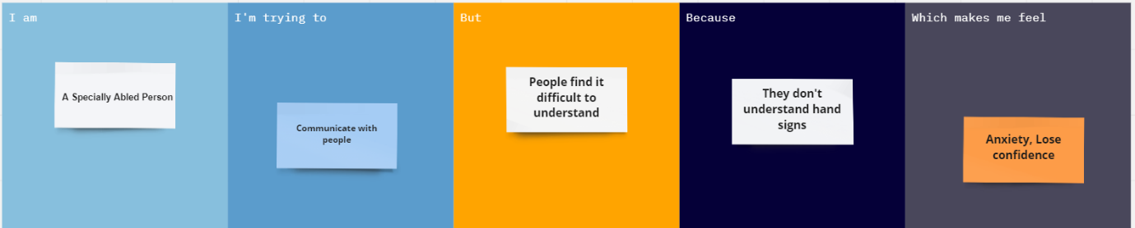

|  |  |
| --- | --- |
| **Problem Statement (PS):** | People with disabilities are not able to communicate with the people and society. Though technologies are evolving but there is no significant growth for these people. So, an AI system is developed to communicate with people in real time. |
| **I am**  **(Specially abled person)** | A Specially abled person, who finds difficulties in communicating with the people and couldn’t able to convey what they feel. And so, the talented ones not able to express what they feel. |
| **I’m trying to** | Communicate with normal persons to convey the information which I intend to. |
| **But** | I can't able to communicate easily with the people and they find it difficult to understand. |
| **Because** | Only few knows the hand sign language not most of the people knows. So, it is a problem that every impaired person has. |
| **Which makes me feel** | Frustrated, Lose confidence, Anxiety. |